**Using .boto**

1. Run start.sh

It will prompt you to enter gs_access_id and gs_secret_access_key. I am encrypting gs_secret_access_key using sha256.

The shell script then runs write_to_boto.py which will save these encrypted credentials to your local .boto config file as shown below:

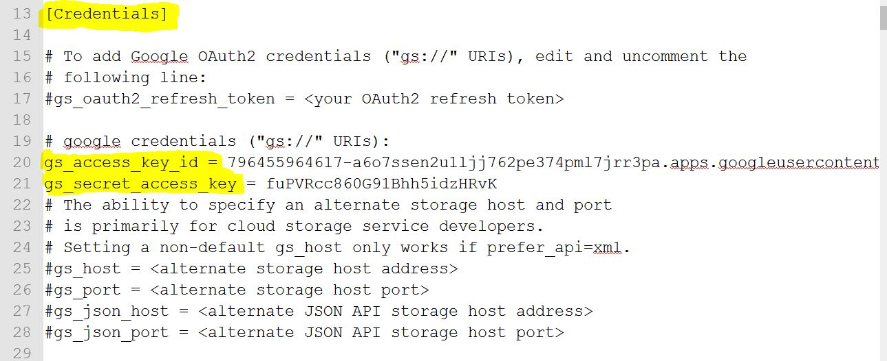

2. Run bucket_operations.sh

The shell script runs read_from_boto.py to decrypt the credentials on the fly. I have written a demo code for fetching the bucket content.

**PS: This doesn't run now because authorization to gsutil fails with 403 Access Denied error.**

from boto import storage_uri

from gcs_oauth2_boto_plugin import oauth2_plugin

import gcs_oauth2_boto_plugin

content = storage_uri('gs://lavabucket1/?project=project1-159607/hello.txt').get_contents_as_string()

print(content)

**Without Using .boto**

1. By reading the same credentials directly from downloaded file, I am able to generate successful requests.

PFA the code in gsutil_without_boto.py